10.1 SCIENCE 2012
METALS AND NON-METALS TEST

Name: ____________________ Teacher: ___________________ Mark: /61

SECTION A: MULTIPLE CHOICE (3 marks)

Select the best answer for each question below.

1. Select the alloy from the list below.

(a) Aluminium
(b) Copper
(c) Bronze
(d) Mercury

2. Choose the incorrect statement.

(a) Mixtures are not compounds.
(b) Elements are also molecules.
(c) Compounds are also molecules.
(d) Compounds are not molecules.

3. Choose the correct statement.

(a) Steel is an alloy or iron with small amounts of carbon added to it.
(b) The properties of the new alloy are usually not as good as those of the base metal.
(c) Most of the metals around you are pure metals.
(d) An alloy is made up of a small amount of base metal and a lot of another metal added to it.
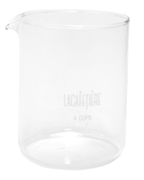

SECTION B: SHORT ANSWER

1. In the beaker on the right, draw an element with 3 atoms. (1 mark)

2. In the beaker on the right, draw a mixture. (1 mark)

3. In the beaker on the right, draw a compound with 3 atoms. (1 mark)

4. Explain the difference between an element and a compound. (2 marks)

_______________________________________________________________________________________

_______________________________________________________________________________________

_______________________________________________________________________________________

5. Explain the difference between a mixture and a compound. (2 marks)

_______________________________________________________________________________________

_______________________________________________________________________________________

_______________________________________________________________________________________

6. Classify the following as either a compound, element or molecule. Some may be more than one. (6 marks)
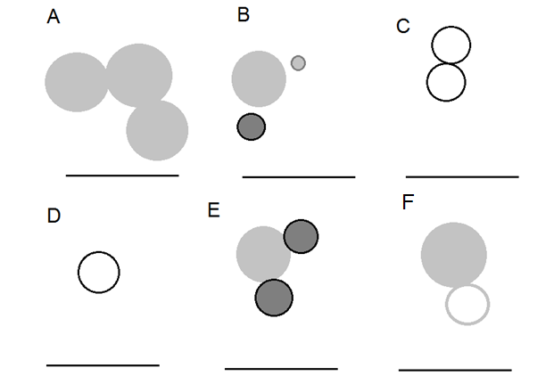

7. Write definitions for the following words.

Ductile: _______________________________________________________________________________________
______________________________________________________________________________________________
___________________________________________________________________________ (2 marks)

Malleable: _____________________________________________________________________________________
______________________________________________________________________________________________
___________________________________________________________________________ (2 marks)

Boiling point: ___________________________________________________________________________________
______________________________________________________________________________________________
___________________________________________________________________________ (2 marks)

Melting point: __________________________________________________________________________________
______________________________________________________________________________________________
___________________________________________________________________________ (2 marks)

Electrical conductivity: ___________________________________________________________________________
______________________________________________________________________________________________
___________________________________________________________________________ (2 marks)

Lustre: ________________________________________________________________________________________
______________________________________________________________________________________________
___________________________________________________________________________ (2 marks)

8. Why can’t most metals be used as pure elements? (1 mark)
______________________________________________________________________________________________
______________________________________________________________________________________________

9. What are ‘alloys’? (2 marks)

______________________________________________________________________________________________
______________________________________________________________________________________________
______________________________________________________________________________________________

10. Brass is 70% Cu and 30%, what element is the base metal? ____________________________ (1 mark)

11. Fill in the table below with the general information. (15 marks)

Characteristic | Metals | Non-metals | Metalloids
Ductile?
(yes or no)
Malleable?
(yes or no)
State in room temperature
Electrical conductivity
(good or poor)
Lustre

11. Fill in the missing spaces. (5 marks)

Compounds are made of ______________ or more different _______________ chemically combined

together. For example, water is made up of two __________________ atoms and one oxygen atom

chemically _____________________ together.

Mixtures are two or more different _________________ mixed together without being

_______________________ combined.

Molecules are one or more ________________ chemically ______________________.

Elements are only made of _______________ type of atom. So gold is made of only ________________
atoms.

12. Write the names of the following elements. (6 marks)
Sn: _________________________ Zn: ________________________
Cu: _________________________ Ni: ________________________
Hg: _________________________ Al: ________________________
Au: _________________________ H: _________________________
N: __________________________ S: _________________________
Si: __________________________ B: _________________________

13. Draw lines to match up the types treatment to their descriptions. (3 marks)
Annealing Heat metal then polish and bend with steel wool.
Tempering Heat metal then allow to cool.
Quenching Heat metal then cool rapidly by dropping into water.

